**SWE30010 Managing IT Projects**

**Sprint Setup Task 9 - Intelligent Chatbot Project**

**Name: Derrick Lu Qing Lee**

**Student ID: 101215931**

**Tutor's Name: Sim Kwan Hua**

**Task 1: Task Board Setup**

**Link : <https://trello.com/b/2bZo4RWh/managing-it-project>**

Task Board Setup Description:

For this task, we used Trello to organize our sprint tasks. The task board includes the following columns:

- Product Backlog Items: Lists high-level project features and requirements.

- Sprint Backlog Items: Selected features committed to Sprint #1.

- To Do (Tasks): Actionable tasks broken down from the sprint backlog.

- Doing (Tasks): Tasks actively being worked on.

- Testing (Tasks): Tasks undergoing quality checks.

- To Be Confirmed (Tasks): Holds tasks completed but awaiting review.

- Done: Final column for approved tasks after stakeholder review.

Each task is assigned to relevant team members, and we move tasks across the columns as they progress through the sprint stages. This setup helps us track task status and ensures we meet ourgoals for Sprint #1.

*Day 0 Task Board Screenshot:*

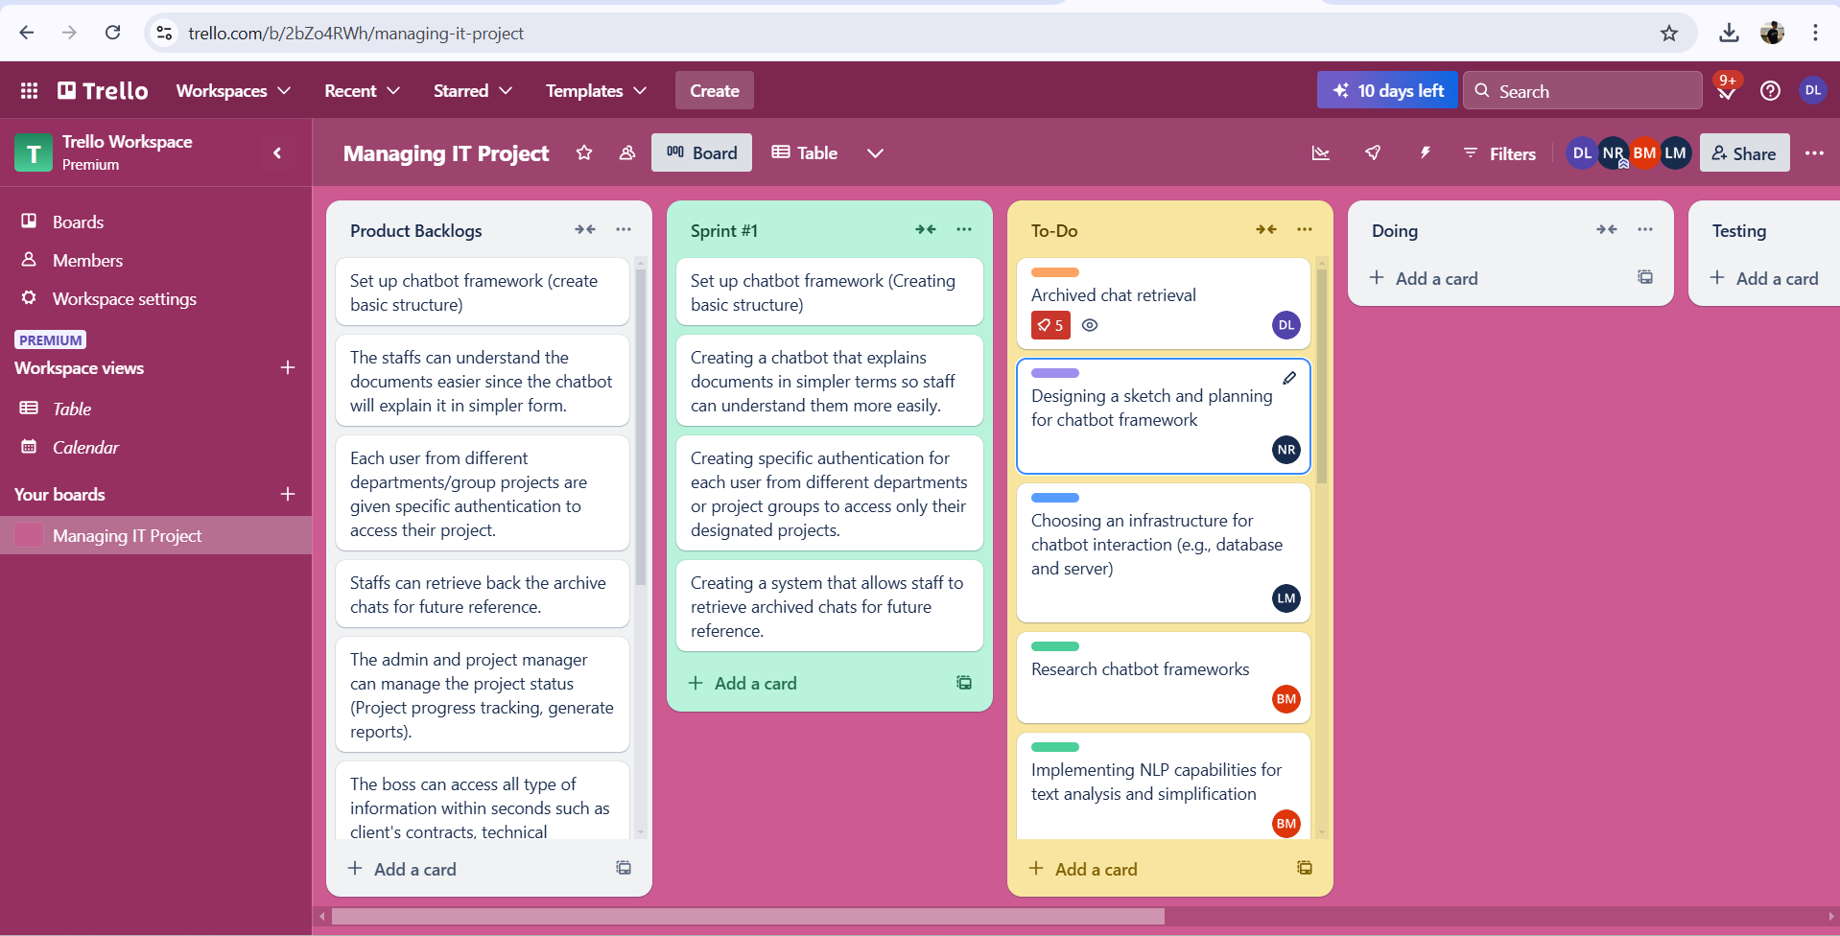

**Task 2: Burn-Down Chart Setup**

**Link : <https://www.burndownfortrello.com/>**

Burn-Down Chart Setup Description:

We used Burndown for Trello to track our sprint progress. The burn-down chart helps us visualize the completion of tasks over the sprint duration. Starting from 64 hours (8 hours per person per week in a 4-member team), the ideal line on the chart represents a steady decrease in hours as tasks are completed. Each team member logs task hours daily, updating the actual progress line to reflect remaining hours. This tool ensures we stay on track to complete our sprint workload by balancing effort daily.

*Day 0 Burn-Down Chart Screenshot:*

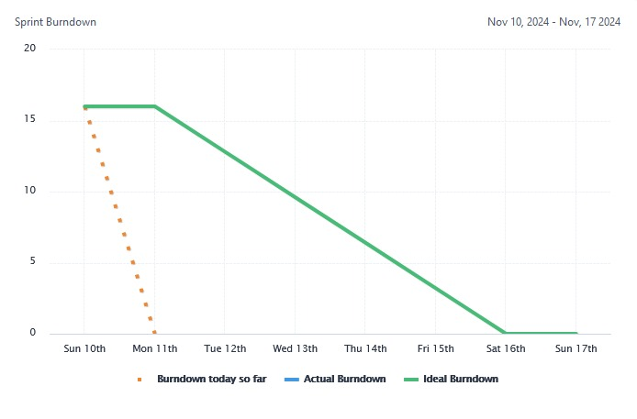

**Task 3: Project Repository Setup**

**GitHub Repository for Intelligent Chatbot Project**  
Link: <https://github.com/derricklu666/SWE30010-Sprint1>

**Description**: This GitHub repository contains the files and code for Intelligent Chatbot project. The repository will be updated regularly with project files, documentation, and code related to the chatbot's development. The goal is to create a chatbot that assists Mr. Lei's team in managing project information efficiently.

*GitHub repository Screenshot:*

